**LAB EXPERIMENT – 3**

**NMAP – (Metasploitable 2.0)**

Nmap, short for "**Network Mapper**," is a powerful open-source tool used for network discovery and security auditing. It's widely used by network administrators, security professionals, and hackers alike. Nmap allows users to discover devices and services running on a network, as well as gather information about them.

Here are some common uses of Nmap:

* Network Discovery: Nmap can scan networks to discover hosts, services, and open ports. This is useful for network inventory and mapping.
* Port Scanning: It can scan for open ports on a target system, helping to identify potential vulnerabilities and services running on those ports.
* Service Version Detection: Nmap can attempt to determine the version of services running on open ports, which can help in vulnerability assessment and patch management.
* OS Detection: Nmap can sometimes identify the operating system running on a target host by analyzing network responses.
* Scripting: Nmap comes with a scripting engine called Nmap Scripting Engine (NSE), which allows users to write and execute scripts to automate tasks, perform advanced network scans, and gather more information from the target systems.
* Firewall Detection: It can sometimes detect the presence of firewalls and other security devices by analyzing responses to its probes.

*Keep in mind that while Nmap is a valuable tool for network administrators and security professionals, its powerful capabilities can also be misused by malicious actors. Therefore, it's essential to use Nmap responsibly and ethically, respecting the laws and regulations governing network security and privacy.*

**Enhanced Scan Results:** The output of Nmap scans performed with the -sC option can include additional information gathered by the default scripts, providing users with more comprehensive scan results.

**COMMAND USED - Nmap -sC 192.168.79.129**

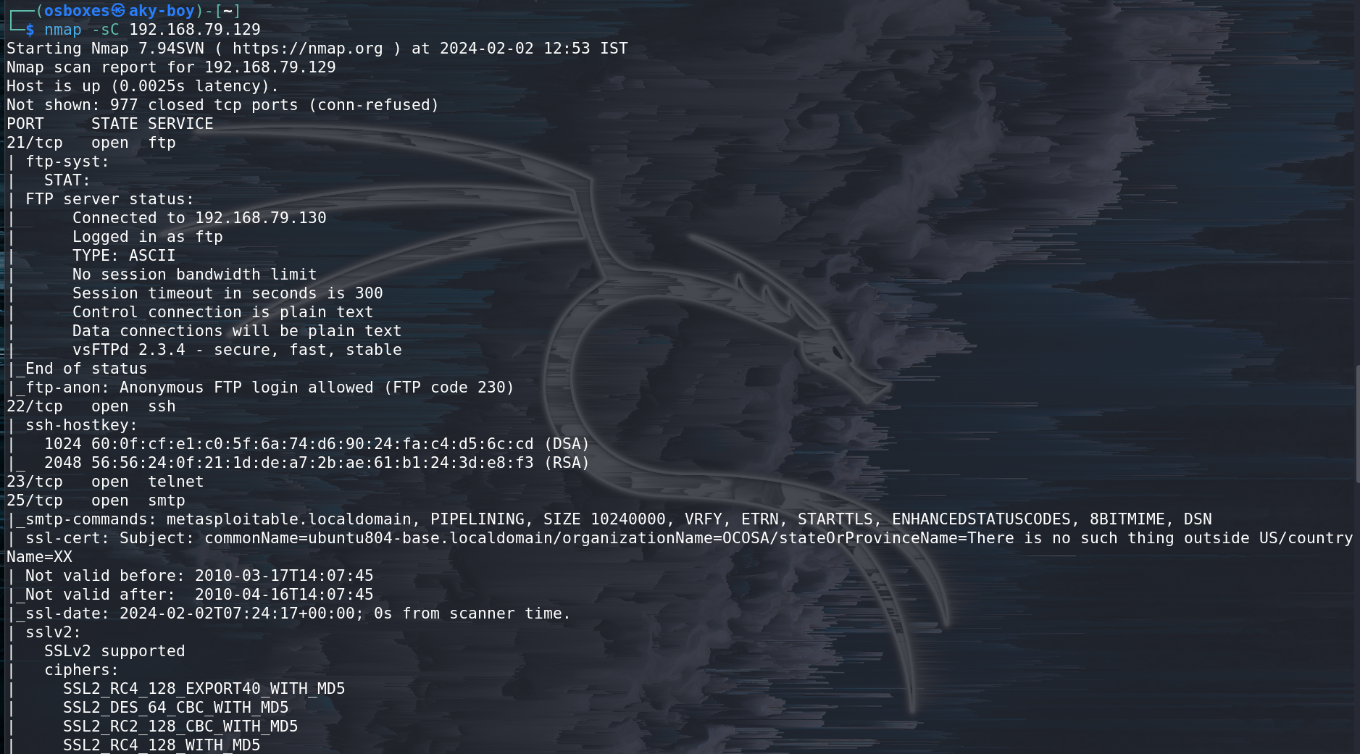

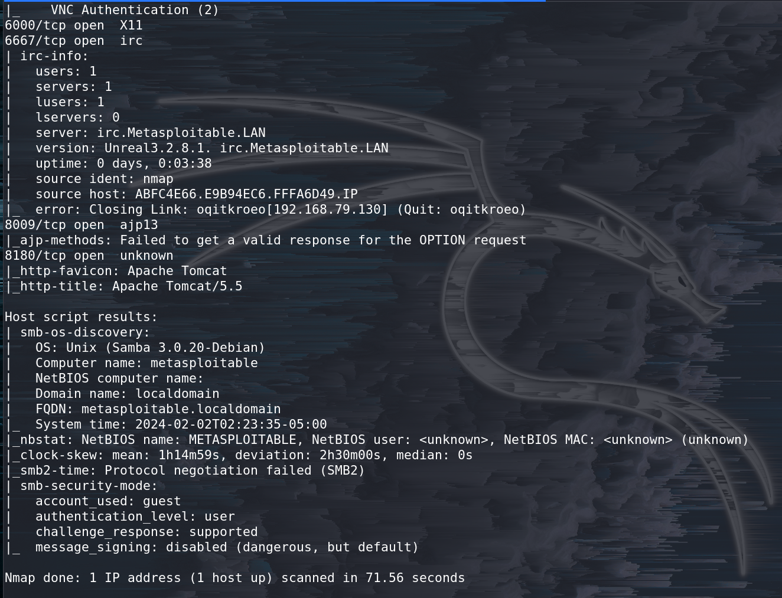

**Service Version Detection:** After identifying open ports, you can use Nmap to detect the versions of the services running on those ports. This can help identify known vulnerabilities associated with specific software versions.

**COMMAND USED - Nmap -sV 192.168.79.129**

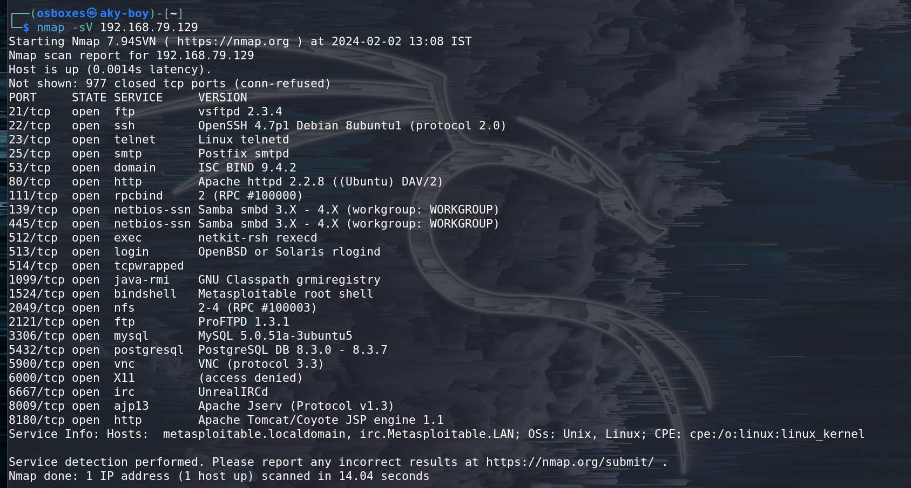

**Port Scanning:** Once you've identified the IP address of the Metasploitable machine, you can conduct a port scan to identify open ports and services.

**COMMAND USED - Nmap 192.168.79.129 -sS -p 80**

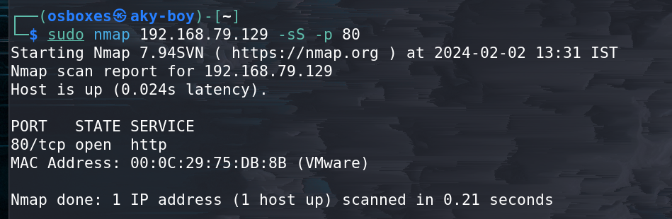

**Vulnerability Scripting:** Nmap's NSE (Nmap Scripting Engine) contains scripts that can detect known vulnerabilities on target systems. You can use these scripts to perform targeted vulnerability scans. For example, you can use the vulners script to check for known vulnerabilities:

**COMMAND USED - Nmap -sV –script vulners 192.168.79.129**

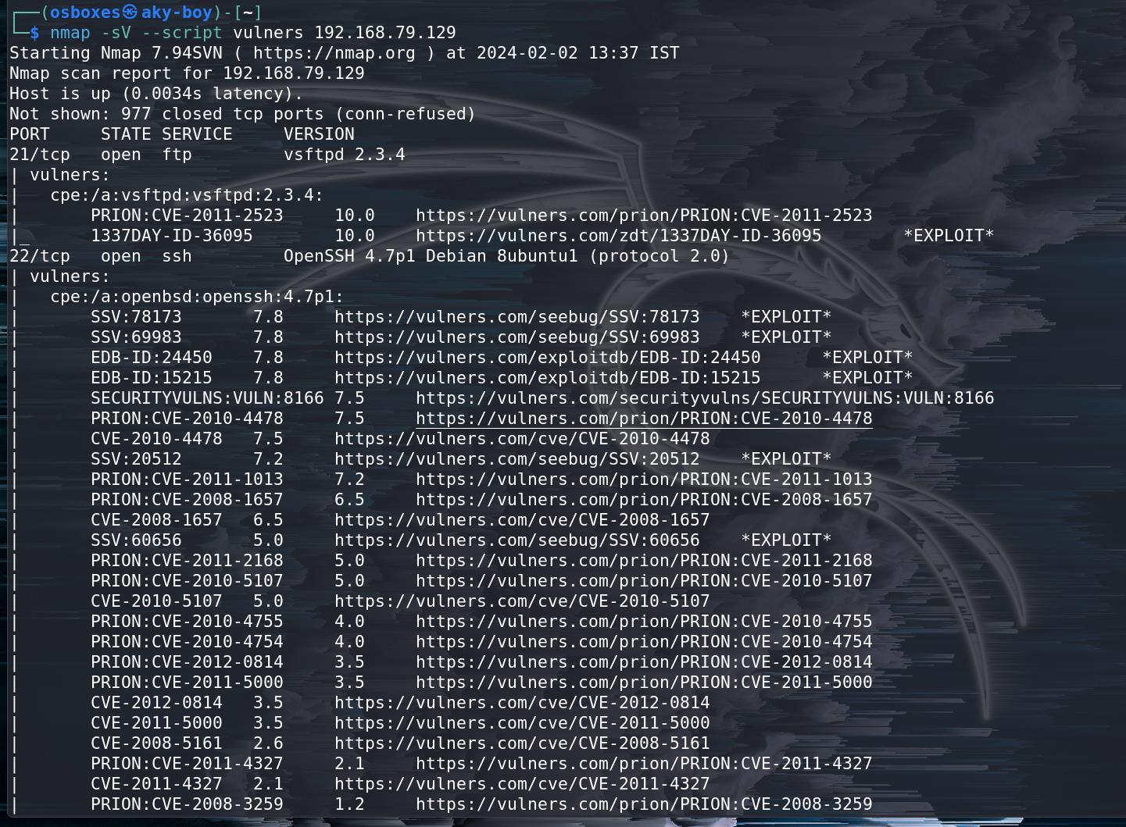

**Information Gathered from Nmap Vulnerability Scans on Metasploitable 2.0**

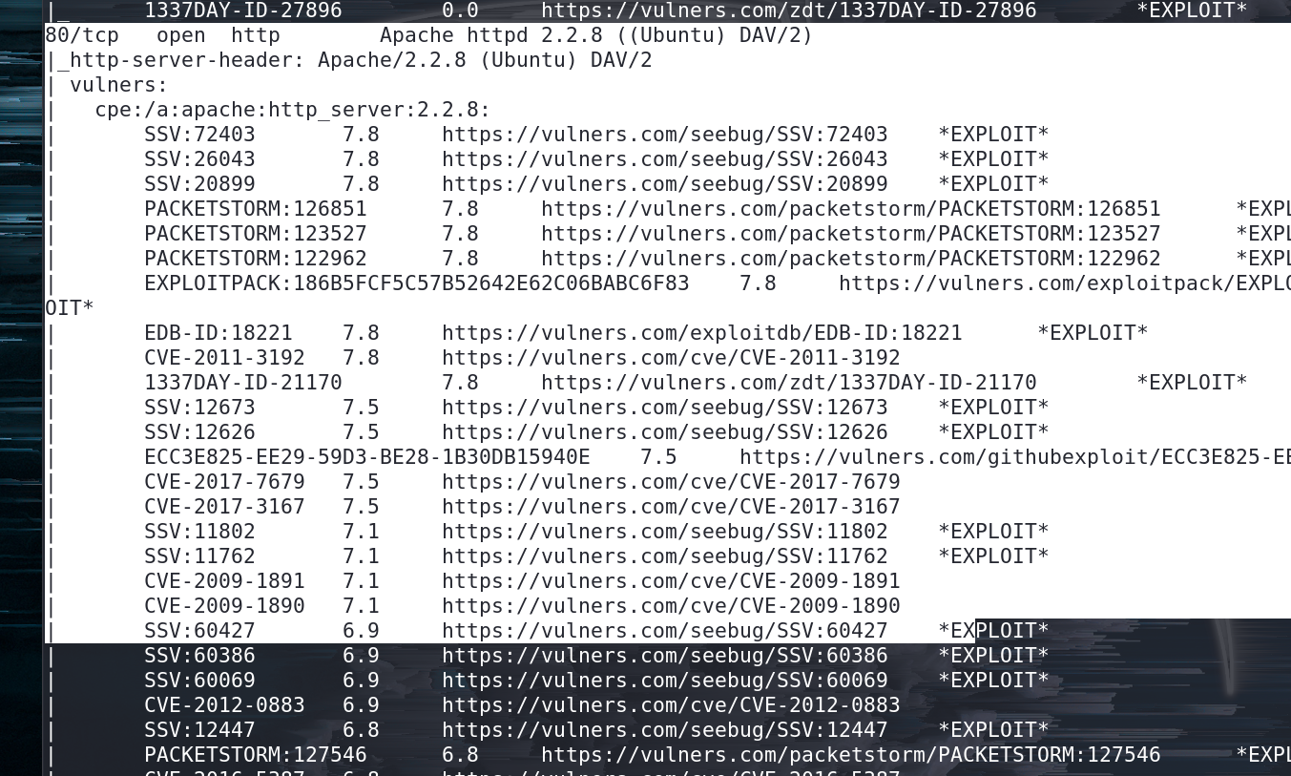

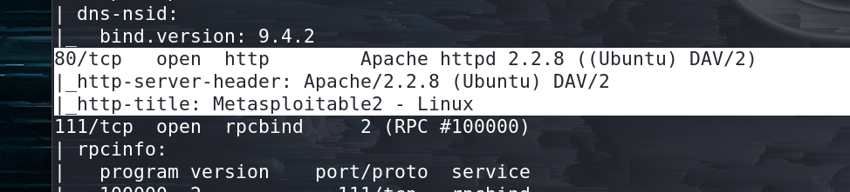

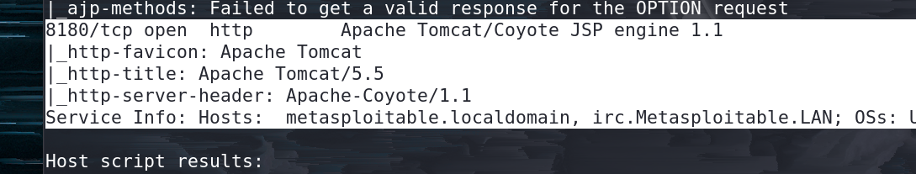

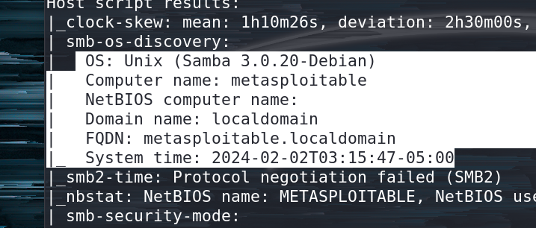

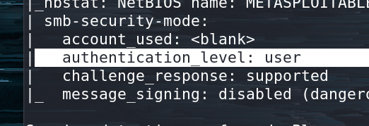

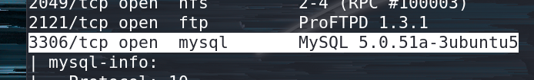

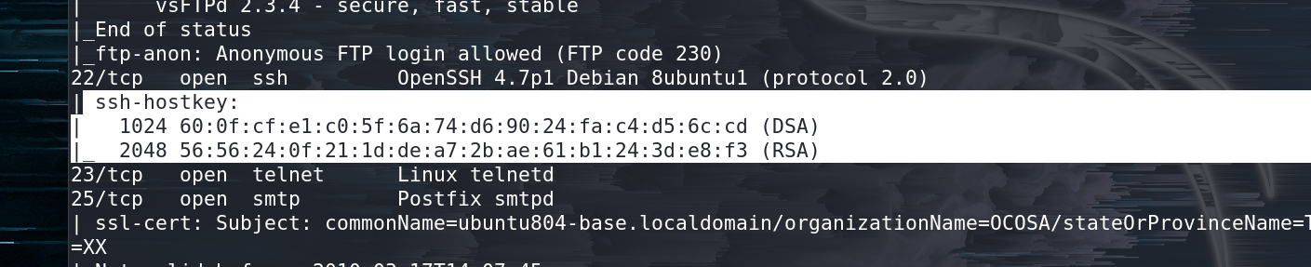

**Vulnerability CVE-2009-1891**



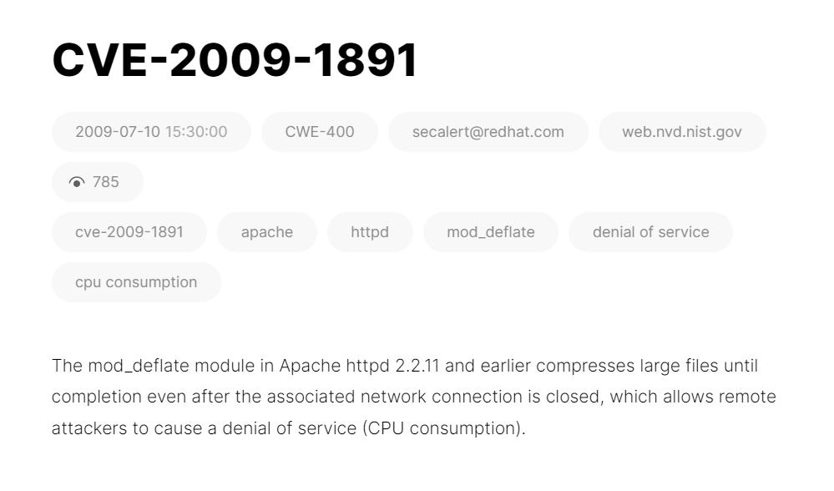

**TCP Scan**

Tcp scan will scan for TCP port like port 22, 21, 23, 445 etc and ensure for listening port (open) through 3-way handshake connection between the source and destination port. If the port is open then source made request with **SYN**packet, a response destination sent **SYN, ACK** packet and then source sent **ACK**packets, at last source again sent **RST, ACK** packets.

Type following NMAP command for TCP scan as well as start Wireshark on another hand to capture the sent Packet.

**Command Used - nmap -sT -p 80 192.168.79.129**

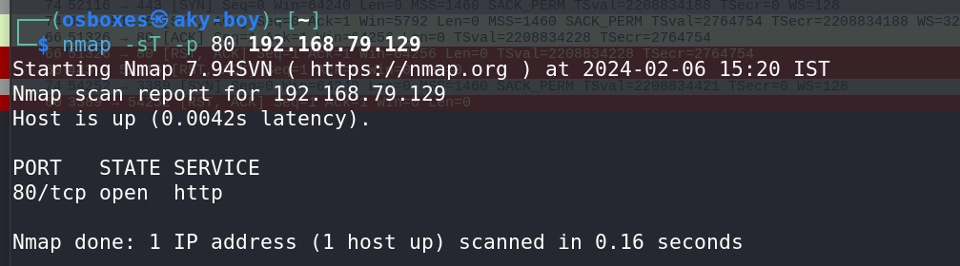The result shows that port 445 is open.

Look over the sequence of packet transfer between source and destination captured through Wireshark.

You will notice that it has captured the same sequence of the flag as described above:

* Source sent SYN packet to the destination
* Destination sent SYN, ACK to source
* Source sent ACK packet to the destination
* Source again sent RST, ACK to destination



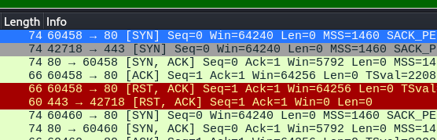

Type following NMAP command for TCP scan as well as start Wireshark on another hand to capture the sent Packet.

**Command Used - nmap -sT -p 3389 192.168.79.129**

The result shows that port **3389** is **closed**.

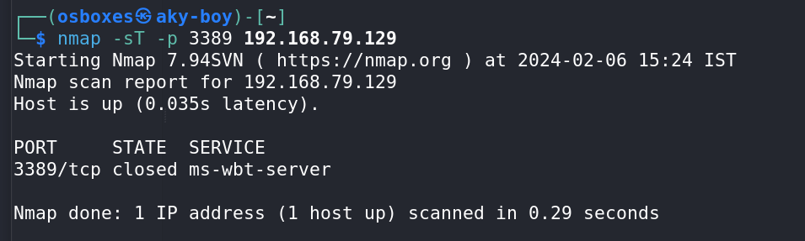

Look over the sequence of packet transfer between source and destination captured through Wireshark.

You will notice that it has captured the same sequence of the flag as described above:

* Source sent SYN packet to the destination
* Destination sent RST, ACK packet to the source

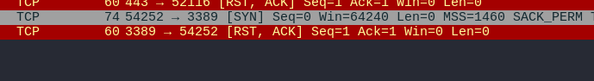

### ****Stealth Scan****

SYN scan is the default and most popular scan option for good reasons. It can be performed quickly, scanning thousands of ports per second on a fast network not hampered by restrictive firewalls. It is also relatively typical and stealthy since it never completes TCP connections.

The port is also considered open if an SYN packet (without the ACK flag) is received in response.

This technique is often referred to as half-open scanning because you don’t open a full TCP connection. You send an SYN packet as if you are going to open a real connection and then wait for a response. An SYN, ACK indicates the port is listening (open)

Type following NMAP command for TCP scan as well as start Wireshark on another hand to capture the sent Packet.

**Command Used - nmap -sS -p 22 192.168.79.129**

From the given image you can observe the result that port **22** is **open.**

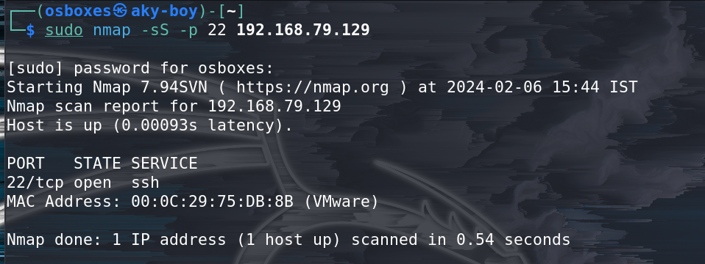

Look over the sequence of packet transfer between source and destination captured through Wireshark

* Source sent SYN packets to the destination
* Destination sent SYN, ACK packets to the source
* Source sent RST packets to the destination

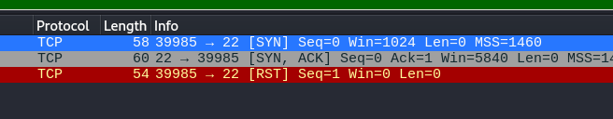

Now figure out traffic for close port using stealth scan. When source sent SYN packet on the specific port then if the port is closed then the destination will reply by sending RST packet.

### ****Fin Scan****

A FIN packet is used to terminate the TCP connection between the source and destination port typically after the data transfer is complete. In the place of an SYN packet, Nmap starts a FIN scan by using a FIN packet.  If the port is open then no response will come from destination port when FIN packet is sent through source port.

**Fin-Scan are only workable in Linux machines and does not work on the latest version of windows**

Type following NMAP command for TCP scan as well as start Wireshark on another hand to capture the sent Packet.

**Command Used - nmap -sF -p 22 192.168.79.129**

From the given image you can observe the result that port **22** is **open.**

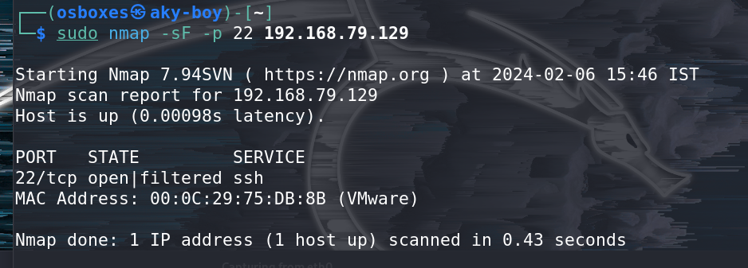

Look over the sequence of packet transfer between source and destination captured through Wireshark

* Source sent FIN packets to the destination
* Destination sent no reply to the source

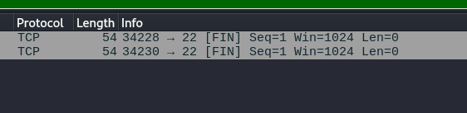

### ****Null Scan****

A Null Scan is a series of TCP packets which hold a sequence number of “zeros” (0000000) and since there are none flags set, the destination will not know how to reply the request. It will discard the packet and no reply will be sent, which indicate that the port is open.

**Null Scan is only workable in Linux machines and does not work on latest version of windows**

Type following NMAP command for TCP scan as well as start Wireshark on another hand to capture the sent Packet.

**Command Used - nmap -sN -p 22 192.168.79.129**

From the given image you can observe the result that port **22** is **open.**

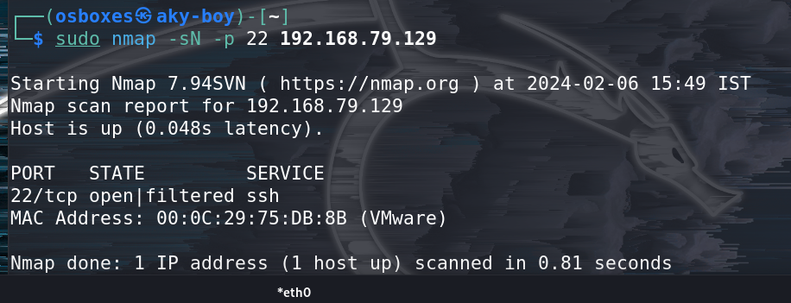

Look over the sequence of packet transfer between source and destination captured through Wireshark

* Source sent Null packets to the destination
* Destination sent no reply to the source

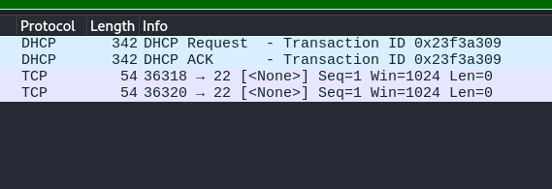

If the port is closed, the Destination will send an RST, ACK packet in response when source send null packets on a specific port

### ****Xmas Scan****

These scans are designed to manipulate the PSH, URG and FIN flags of the TCP header, Sets the FIN, PSH, and URG flags, lighting the packet up like a Christmas tree. When source sent FIN, PUSH, and URG packet to a specific port and if the port is open then destination will discard the packets and will not send any reply to the source.

**Xmas Scan is only workable in Linux machines and does not work on the latest version of windows**

Type following NMAP command for TCP scan as well as start Wireshark on another hand to capture the sent Packet.

**Command Used - nmap -sX -p 22 192.168.79.129**

From the given image you can observe the result that port **22** is **open.**

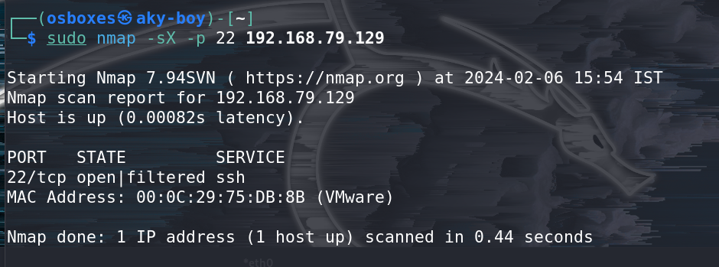

Look over the sequence of packet transfer between source and destination captured through Wireshark

* Source sent FIN, PUSH and URG packets to the destination
* Destination sent no reply to the source

